Test number ________________________
Final Exam VERSION A
Print your name: ______________________________________________________
Course section number: _______________ Date: __________________________

My signature indicates that I have neither given nor received aide on this exam. I understand that sharing the contents of this exam with any other student is a violation of the academic code and could result in failure in this course.

Student Signature Required ____________________________________________

Section 1: Read each question carefully and consider each answer choice before selecting the most suitable one.

- The symbol for the unit of electrical resistance is :
  - C
  - W
  - Ω
  - A
  - V

- Which electrical component converts chemical energy to electrical energy
  - Battery
  - Motor
  - Generator
  - Amplifier
  - Resistor

- Ohm's law gives the relationship between
 | a. | work and voltage.
 | b. | current and voltage
 | c. | current and charge.
 | d.  e. | force and current.  Work and power
- How many electrons are represented by a charge of 250 mC.
  - 3.00 x 10¹⁷ electrons
  - 1.56 x10¹⁹ electrons
  - 1.56 x 10¹⁸ electrons
  - 4.00 x 10¹⁹ electrons
  - 4.00 x 10¹⁸ electrons

- What causes the production of electricity in a metallic conductor
  - Protons
  - Electrons
  - Neutrons
  - Quarks
  - Positron

- What circuit element is represented by the following circuit symbol?

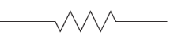
  - Resistor
  - Capacitor
  - Inductor
  - Lamp
  - Switch

- In the diagram given below, I₁ =12 A, I₂ =10 A, I₃ =17 A, I₄ = 7 A. Find the current I₅.
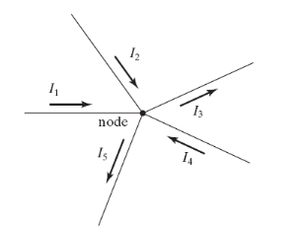
  - -12 A
  - -10 A
  - 10 A
  - 17 A
  - 12 A

- Direct current (DC) and alternating current (AC) are the two major types of current in use in various electrical devices. Identify the waveform for sawtooth direct current (DC).
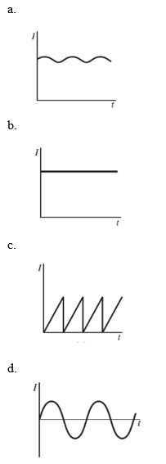

- Three resistors, 40 Ω, 5 Ω, and 35 Ω, are wired in parallel and connected to a 60-V battery. How much current flows in this circuit?
 | a. | 0.75 Α
 | b. | 15.2 Α
 | c. | 950 Α
 | d.  e. | - Α  - A

- Calculate the magnitude of the voltage V₂ in the following circuit
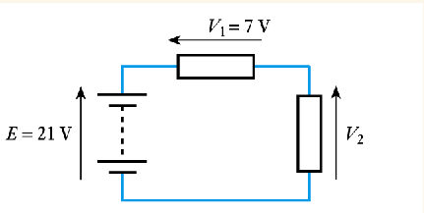
- 28 V
- -14 V
- 14 V
- -7 V
- -28 V

- Temperature can't be lower than
  - 0 °C
  - 0 °F
  - 0 K
  - 0 °R
  - Both a and c

- What is the symbol for internal energy?
  - U
  - I
  - H
  - E_{k}
  - E_{p}

- Potential energy and kinetic energy are types of
  - Electrical Energy
  - Magnetic energy
  - Thermal energy
  - Mechanical energy
  - Gravitational Energy

- The first law of thermodynamics states that:
  - Energy cannot be converted or transferred
  - Energy cannot be destroyed or transferred
  - Energy cannot be created or transferred
  - Energy cannot be created or destroyed
  - None of the above.

- In a typical power station, amid a series of energy transfers and conversions, about 70% of energy input gets wasted in form of thermal energy, efficiency of such a power station is about
  - 0.3
  - 0.7
  - 1.0
  - 0.4
  - 1.1

- Atmospheric pressure at sea level is
  - 1.013 x10² Pa
  - 1.013 x10⁴ Pa
  - 1.013 x10⁵ Pa
  - 1.013 x10⁶ Pa
  - 1.013 Pa

- Steam point is equal to 100 °C, which is equal to
  - −373 K
  - −173 K
  - 100 K
  - 373 K
  - 173 K

- An example of a material that transfer heat well is
  - Styrofoam
  - Copper
  - Wood
  - Water
  - All of the above
- The equation, $P.E = mgz$, represent which type of potential energy
  - gravitational potential energy
  - chemical potential energy
  - mechanical potential energy
  - nuclear potential energy
  - none of the above

- The equation $e=gz+v^{2} +u$ represents the total energy on a per unit mass basis. What name is given to the variable symbolized by “e”?
- Total energy
- Internal energy
- Specific total energy
- Specific internal energy
- Chemical energy

- What is the SI units of density?
  - g/cm³
  - slug/ft³
  - kg/m³
  - kg/L
  - g/mL

- Properties of fluids determine the use of fluids in engineering and technology. Which of the following are important fluid properties?
  - Density and Pressure
  - Specific gravity and specific weight
  - Temperature and viscosity
  - Bulk modulus and specific volume
  - All of the above

- What are the SI units of specific weight?
  - kg/m³
  - N/m³
  - lb_{f}/ft³
  - m³/kg
  - slug/ft³

- Specific weight is defined as:
  - Mass per unit volume
  - Weight per unit volume
  - Ratio of the density of a fluid to the density of water at a reference temperature
  - Ratio of the change in volume of a fluid to change in pressure
  - Volume occupied per unit mass
- Which of the following statements correctly describe the relation between temperature and viscosities of liquids and gases?
  - Viscosity increases with the increase in temperature of liquids and decreases with the increase in temperature of gases
  - Viscosity increases with the increase in temperature of liquids and increases with the increase in temperature of gases
  - Viscosity decreases with the increase in temperature of liquids and decreases with the increase in temperature of gases
  - Viscosity decreases with the increase in temperature of liquids and increases with the increase in temperature of gases
  - None of the above

- Systematic errors can be removed by
  - buying new instrument
  - breaking instrument
  - dusting instrument
  - recalibrating instrument
  - none of the above

- A graduated cylinder containing 100 mL of alcohol has a combined mass of 280 g. If the mass of the cylinder is 200 g, what is the specific weight?
  - 7.848 x 10⁶ N/m³
  - 7.848 x 10⁻⁶ N/m³
  - 7.848 x 10³ N/m³
  - 7.848 x 10⁻³ N/m³
  - 0.7848 N/m³

- Glycerin at 20°C (ρ = 1260kg/m³, μ = 1.48Pa⋅s) occupies a 1.6-mm space between two square parallel plates. What is the kinematic viscosity of the glycerin?
  - 1.175 x 10⁻³ m²/s
  - 851 m²/s
  - 1.175 x 10³ m²/s
  - 1.175 m²/s
  - 8.51 m²/s

- Which is a general conclusion from the relationship between pressure and elevation
  - The pressure-elevation equation is only valid for a homogenous static fluid. It does not apply to gases, because $γ$is not constant for compressible fluids.
  - $∆P$ is directly proportional to the specific weight of the liquid
  - Pressure increases with increasing depth and vice versa
  - Points on the same horizontal plane have the same pressure
  - All of the above
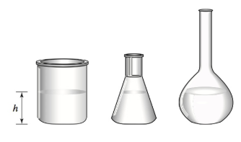
- For the containers shown below which statement(s) is correct about the pressure of a liquid.

  - Pressure is a function of elevation only
  - Pressure depends on the size of the container
  - Pressure is a function of the shape of the container
  - All of the above
  - None of the above

- A small dam consists of a vertical plane wall with a height and width of 5 m and 30 m, respectively. The depth of the water (γ=9.81kN/m³) is 4 m. Find the resultant force on the wall.
  - 235 MN
  - 2.35 MN
  - 0.235 MN
  - 0.0235 MN
  - 0.00235 MN

- A small dam consists of a vertical plane wall with a height and width of 5 m and 30 m, respectively. The depth of the water (γ=9.81kN/m³) is 4 m. Find the center of pressure, $Z_{cp}$.
  - 0.267 m (from the free surface
  - 267 m (from the free surface)
  - 26.7 m (from the free surface)
  - 2.67 m (from the free surface
  - 2670 m (from the free surface)

- Which equation shows the relationship between mass flow rate and volume flow rate?
  - $\dot{m}=ρ/\dot{V}$
  - $\dot{m}=\dot{V}/ρ$
  - $\dot{m}=ρ\frac{v}{A}$
  - $\dot{m}=A\dot{V}$
  - $\dot{m}=ρ\dot{V}$

- The reason for organizing, analyzing, and classifying data is:
  - so that computers can be used.
  - to prove a law.
  - to find relationships among the data.
  - to separate qualitative and quantitative data
  - None of the above

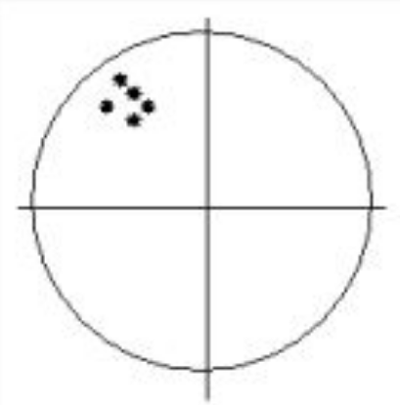
- Looking at the rifle target below, how would you describe the shooting of this contestant?
- Accurate and precise
- Inaccurate and precise.
- Accurate and imprecise.
- Inaccurate and imprecise.
- None of the above

- What is error?
  - lack of bias in data
  - quality of measured data
  - deviation of a measured value from the true or correct value
  - the closeness of a measured value to the true value
  - all of the above

- When classifying data to prepare a histogram, the least number of class is____________
  - Five
  - Six
  - Seven
  - Eight
  - Nine

- Which of the following types of errors is traced to a defect in the measuring instrument?
  - Random
  - Gross
  - Systematic
  - Propagated
  - All of the above

- Graph paper where the horizontal and vertical grid lines are equally spaced.
  - Semilog graph paper
  - Linear graph paper
  - Full-log paper
  - Both a and b
  - All of the above

- Which of the following information should be recorded in a bound laboratoty notebook:
  - Title of experiment
  - Page number
  - Date
  - Type of instrument used
  - All of the above

- In an experiment, the variable that is manipulated is called the…
  - Dependent variable
  - Confounding variable
  - Independant variable.
  - Co-variable
  - Independent variable.

- All are steps in the method of selected points, except:
  - plot data
  - draw straight best fit line by eye using a transparent ruler
  - select two points on the line
  - write and solve equations for m and b
  - determine the coefficient of determination

- Identify the type of frequency distribution illustrated below.
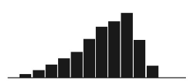

- Right skewed
- Left skewed
- Truncated
- Normal
- Uniform

- Given the data set, find the mean
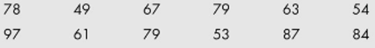

- 70
- 71
- 72
- 73
- 74

- Given the data set, find the mode

  - 78
  - 79
  - 63
  - 61
  - 5

- Given the data set, find the median

- 72.5
- 72
- 67
- 78
- 73

- Which is not a measure of central tendency?
  - Variance
  - Mean
  - Median
  - Mode
  - Both c and d
- Which is not a characteristic of statistics?
  - A process that provides information that is incomplete and imperfect
  - A process that provides the absolute truth
  - A process that enables us to make scientifically honest assessments about the likelihood of certain phenomena.
  - A process in which we seldom know or can measure all the influential variables that affect the phenomena.
  - None of the above

- If the standard deviation of a population is 9, the population variance is:
  - 9
  - 3
  - 21
  - 81
  - 24

- Sum of all squared deviations is divided by total number of observations to calculate
  - population deviation
  - population variance
  - sample deviation
  - sample variance
  - none of the above

Section 2: Read each question carefully, then show all work to get full credit. Ensure that you write down the equation you will use to solve the problem and use the appropriate units

- Circuit Analysis
- Evaluate the voltage and current each resistor (5 points)
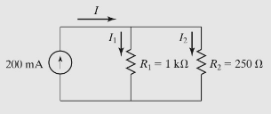

- For the DC circuit shown in the Figure below, find the voltage across each resistor and the current in each resistor. (10 points).

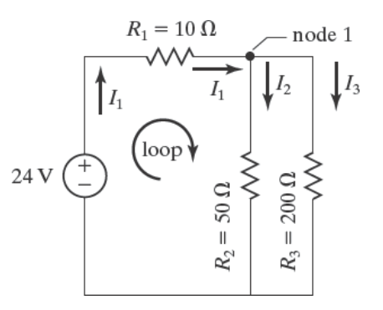

- Thermodynamics
  - A pressure gauge connected to a tank reads 50 psi at a location where the atmospheric pressure is 0.972 atm. Determine the absolute pressure in the tank. (5 points)

  - A 1200-kg automobile accelerates up a hill, increasing its speed from 2.235 m/s to 20.12 m/s, along a straight 100-m stretch of road. If the hill makes an angle of 6° with respect to the horizontal, find the total work done by the automobile. (5 points)

  - Joe, a backyard tinkerer who fancies himself an engineer, tells his engineer neighbor Jane that he has developed a heat engine that receives heat from boiling water at 1 atm pressure and rejects heat to a freezer at -5°C. Joe claims that his heat engine produces 1 Btu of work for every 2.5 Btu of heat it receives from the boiling water. After a quick calculation, Jane informs Joe that if he intends to design heat engines, he needs to pursue an engineering education first. Is Jane justified in making this comment? Justify your answer by analysis. (10 points)

- Fluid Mechanics
  - The fuel tank of a truck has a capacity of 95.6 gal. If the tank is full of gasoline (sg = 0.751), what is the mass and weight of the gasoline in SI units? (5 points).

  - Use the seven step general analysis Procedure to solve the problem presented below:
  - Problem Statement
A converging rectangular duct carries nitrogen (ρ = 1.155 kg/m³ ) at a mass flow rate of 4 kg/s. The small section of the duct measures 30 cm × 40 cm, and the large section measures 50 cm × 60 cm. 50 cm×60 cm. Find the volume flow rate and the average velocities in each section.
  - Diagram
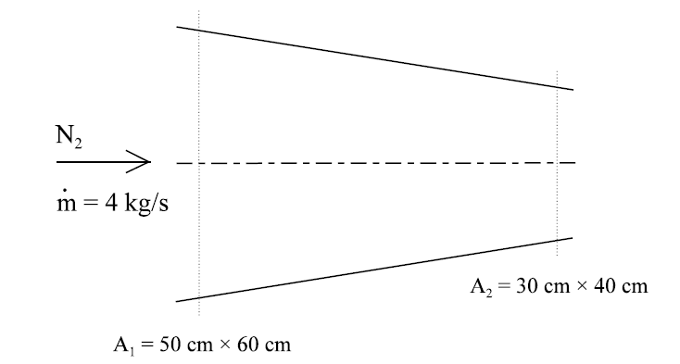
  - Assumptions
    - Steady incompressible flow
    - Constant nitrogen properties

  - Governing Equations

  - Calculations

Solution Check

Discussion

- As the accompanying table shows, the power dissipated by a large transformer with a resistance of 5 Ω is measured for several values of current that passes through the transformer’s windings. Using the method of selected points, determine a mathematical function that fits the data.
Current, I (A) | Power, P (W)
1.05 | 5.63
1.25 | 7.58
1.75 | 16.9
2.50 | 32.1
3.0 | 48
4.0 | 78.2
5.0 | 126.0
6.0 | 188.0
8.0 | 315.1
10.0 | 490.3

- Plot the graph with a linear scale in Excel. Does the data suggest a linear function? If not what kind of function does it suggest? Print and attach graph to test for submission. (5 points)
- If it is not linear, plot the data on a full log scale. To get the full log scale follow these instructions in Excel: (5 points)
  - Right click on the x-axis and select format axis and select logarithmic scale
  - Repeat the same for the Y-axis
  - Fit the data with the linear trend line
  - Print and attach graph to test for submission
- Use the linearize graph and the method of selected points, determine a mathematical function that fits the data. Show your work in this determination (10 points)

Temperature, T($℃)$ | Voltage, V (mV)
50 | 1.08
100 | 4.35
200 | 7.76
300 | 12.51
400 | 16.70
500 | 19.62
700 | 29.43
1000 | 42.02
- Using least squares linear regression, find the mathematical function that fits the data set tabulated below and find the coefficient of determination. Show all calculations and attach relevant spread sheet and graph. (20 points)

- The table below shows the variation of the specific heat of liquid water with temperature. Using linear interpolation, calculate the specific heat for temperatures of 27, 125, and 192⁰C.
Temperature, T(⁰C) | Specific Heat, c(kJ/Kg$⋅℃)$
0 | 4.217
10 | 4.193
20 | 4.182
30 | 4.179
50 | 4.181
100 | 4.216
150 | 4.310
200 | 4.497

- The weights (in oz.) of filled soup cans as they come off the production line are given in the table below. Subdivide the weights into at least six classes and construct a histogram. Print the histogram and submit it with your test.(10 points)

15.73 | 16.25 | 16.10 | 16.69 | 16.05 | 15.92 | 16.10 | 16.30
15.30 | 15.02 | 15.85 | 16.23 | 16.80 | 16.40 | 15.91 | 15.42
15.70 | 16.10 | 16.23 | 16.33 | 16.66 | 15.70 | 15.85 | 16.20
16.41 | 16.54 | 16.37 | 15.80 | 16.19 | 16.33 | 15.81 | 16.18

For the data in the table above find: (Show your work)
  - The mean (1 point)

  - The median (1 point)
  - Mode (1 point)
  - Standard deviation (5 points)

  - The variance (1 point)

Bonus Question
- Using the tables given under the useful equations, find the area under the normal curve in each case (c) and (d). (10 points)

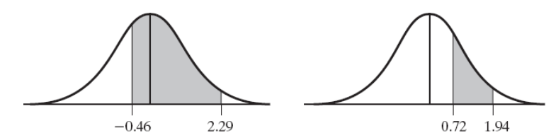
(c) (d)

Useful Equations
- $I= \frac{q}{t}$
- $1\acute{e}={1.602×10}^{-19 }C$
- $V=\frac{W}{q}$
- $V=IR$
- $P=IV=I^{2}R=\frac{V^{2}}{R}$
- $R_{s}=R_{1}+R_{2}+R_{3}+$………..
- $\frac{1}{R_{p}}=\frac{1}{R_{1}}+\frac{1}{R_{2}}+\frac{1}{R_{3}}+$………..
- $\sum{I_{in}}=0=I_{1}+I_{2}+I_{3}+I_{4}+…$
- $P=\frac{F}{A}$
- $P_{gauge}=P_{abs}-P_{atm}$
- $P_{vac}=P_{atm}-P_{abs}$
- $T\left(K\right)=T\left(℃\right)+273.15$
- $T\left(°R\right)=T\left(℉\right)+459.57$
- $T\left(°R\right)=1.8T\left(K\right)$
- $T\left(℉\right)=1.8 T\left(℃\right)+32$
- $K.E=\frac{1}{2} mv^{2}$
- $W_{g}=mg(z_{2}-z_{1})$
- $W_{a}=\frac{1}{2}m(v_{2}^{2}-v_{1}^{2})$
- $\left(Q_{in}-Q_{out}\right)+\left(W_{in}-W_{out}\right)=∆U$
- $∆U=U_{1}-U_{2}$
- $Q_{in} = Q_{out} + W_{out}$
- $η_{th}=\frac{W_{out}}{Q_{in}}$
- $η_{th}=\frac{Q_{in}-Q_{out}}{Q_{in}}=1-\frac{Q_{out}}{Q_{in}}$
- $η_{th, ideal}==1-\frac{T_{L}}{T_{H}}$
- $ρ=\frac{m}{V}$
- $W=mg$
- $γ=\frac{W}{V}$
- $γ=ρg$
- $sg=\frac{ρ_{fluid}}{{ρH}_{2}O, 4℃}$ ${ρH}_{2}O, 4℃=1000 kg/m^{3}$
- $sg=\frac{γ_{fluid}}{{γH}_{2}O, 4℃}$ ${γH}_{2}O, 4℃=9810 N/m^{3}$
- $ϑ=\frac{μ}{ρ}$
- $1 m^{3}=264.17 gal$
- $K=\frac{-∆P}{∆V/V}$
- $Δ P = γ h=ρgh$
- $F= PA$
- $F_{R} = \frac{γ h A}{2}$
- $z_{cp}=\frac{2h}{3}$
- $\dot{V}=vA$
- $\dot{m}=ρ\dot{V}$
- $\dot{m}=ρvA$
- $A=πr^{2}$
- $A=π\frac{D^{2}}{4}$
- $1 m=100 cm$
- ${\dot{m}}_{1}+{\dot{m}}_{2}={\dot{m}}_{3}$
- $1 kg=1000$

- Sample mean
$$\overline{x}=\frac{\sum_{i=1}^{n}{x_{i}}}{n}$$
- (population mean)
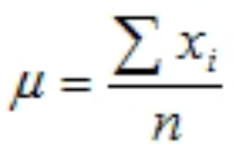
- Sample Standard Deviation
$$s=\left[\frac{\sum{{(x_{i}-\overline{x})}^{2}}}{n-1}\right]$$
- (Population Standard Deviation)
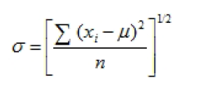
- Polpulation and sample Variance
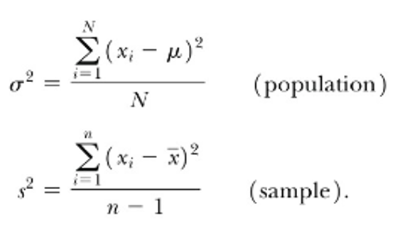
- Z-score

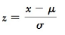

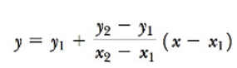
- Linear Interpolation Equation

